HOSPITALITY – Kitchen Operations
SIT20312 Certificate II in Kitchen Operations
Version 15/1
COURSE DETAILS |  |  |  | ABOUT
Hours | 240 hours |  |  |  | This qualification provides a pathway to work in kitchen operations in organisations such as restaurants, hotels, catering operations, clubs, pubs, cafes, cafeterias, coffee shops and institutions such as aged care facilities, hospitals, prisons and schools.  Skills and knowledge will prepare the students in providing effective hospitality service to customers.  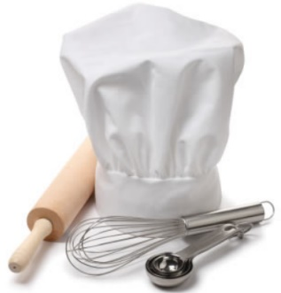  JOB ROLES  Possible job titles include:  - Breakfast cook  - Catering assistant  - Fast food cook  - Sandwich hand  - Take-away cook
Type | Board Developed Course
Duration | 2 years
Unit Value | 2 unit Preliminary  2 unit HSC
Specialisation | Yes
HSC Exam | Yes
ATAR | Yes
Workplacement | Mandatory 70 hours
SBAT | Opportunity to complete a School Based Apprenticeship or a Traineeship and gain credit towards the HSC
RECOGNITION | National and HSC Qualification
ASSESSMENT
Assessment strategies may include:
- Observation
- Student Demonstration
- Questioning
- Written tasks
- Tests

FURTHER STUDY
After achieving SIT20312 Certificate II in Hospitality, individuals could progress to a wide range of other qualifications in the hospitality and broader service industries, for example:
- Certificate III in Commercial Cookery
- Certificate III in Hospitality
- Certificate III in Tourism

PERSONAL REQUIREMENTS
- Enjoy practical work
- Good hand-eye coordination
- Able to work quickly and safely with minimal supervision
- Good personal hygiene
- Free from skin allergies to foods and detergents
- Good communication skills
- Able to work under pressure
- Able to work as part of a team.

CAREER PATHWAYS
Chef, Caterer, Restaurateur/Restaurant/Cafe Owner
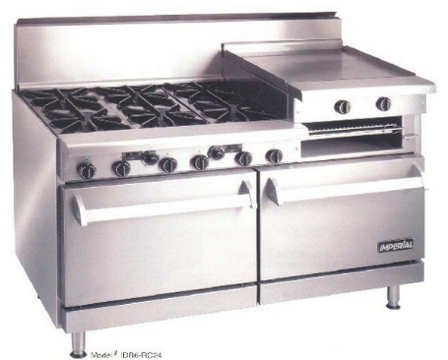
DUTIES AND TASKS OF A KITCHEN HAND
Kitchen hands may perform the following tasks:
- Wash and clean utensils and dishes and make sure they are stored appropriately
- Handle, sort, store and distribute food items
- Wash, peel, chop, cut and cook foodstuffs, and help prepare salads and desserts
- Sort and dispose of rubbish and recycling
- Organise laundering of kitchen linen
- Clean food preparation equipment, floors and other kitchen tools or areas.

STUDENT OUTCOMES for Certificate II in Kitchen Operations
These are the outcomes of graduates surveyed six months after completing their training for Certificate II in Kitchen Operations.
All statistics are supplied by the National Centre for Vocational Education Research

Kitchen Operations: Top Occupations |  | Kitchen Operations: Starting Salary |  |  |  |  |  | Kitchen Operations: Employment Outcomes
http://www.myskills.gov.au/ |  |  |  |  |  | http://training.gov.au

